Mortgage Payment Calculation - Full Answer

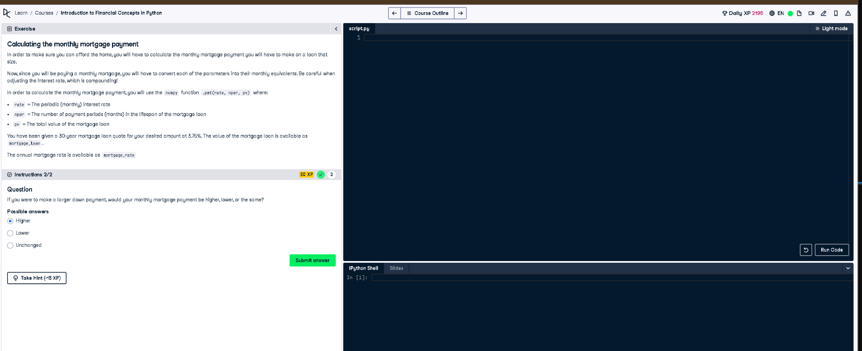

# Full Code Answer:

import numpy as np  
  
# Given data  
mortgage_rate = 0.0375 # Annual interest rate  
mortgage_loan = 300000 # Example total value of mortgage loan  
years = 30 # Mortgage term in years  
  
# Convert annual interest rate to monthly rate  
rate = mortgage_rate / 12  
  
# Total number of monthly payments  
nper = years * 12  
  
# Present value (loan amount)  
pv = -mortgage_loan # Negative because it's an outgoing payment  
  
# Calculate monthly payment  
monthly_payment = np.pmt(rate, nper, pv)  
  
print(f"Monthly Mortgage Payment: ${monthly_payment:.2f}")

# Question:

If you were to make a larger down payment, would your monthly mortgage payment be higher, lower, or the same?

# 20-word Explanation (Question):

A larger down payment reduces the remaining principal balance, which decreases the required monthly mortgage payment over time.

# Answer:

Lower

# 20-word Explanation (Answer):

A larger initial payment means borrowing less money, directly reducing monthly mortgage payments due to a smaller loan balance.